Huntley Parish Council News – March 2026
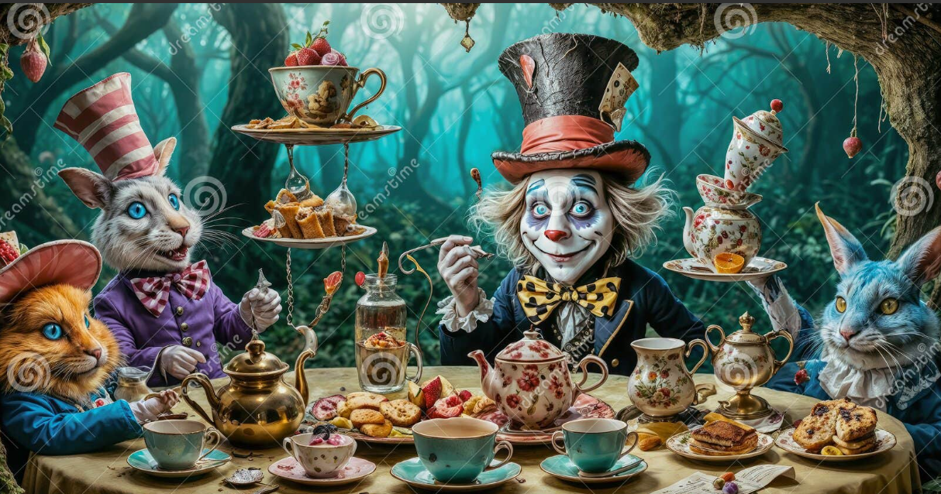
Next Parish Council Meeting  Tuesday 7 April 2026  7:00pm  Huntley Village Hall  Contact Details  Clerk: Liz Tustin  Email: clerk@huntleyparishcouncil.gov.uk  Parish Council Website  www.huntleyparishcouncil.gov.uk |  | This newsletter is produced by Huntley Parish Council and provides a summary of the key topics that the council has worked on during the month.  The Mad Hatter’s Tea Party will take place on Saturday 4 April from 2:00pm to 4:00pm.  This event is being held to raise funds for the play area, football pitch and maintenance of the recreation ground:  Tickets:  £5 per adult  £2.50 for under-fives  Entry is by ticket only.  Please contact any councillor to purchase ticket  Welcome to a New Councillor. The council is pleased to welcome Councillor Charlotte Lipscombe.  The 100 Club will be starting in May. Please contact the Clerk for further details and look out for posters around the village  The council has reviewed the Forest of Dean District Council draft Local Plan. Once the Parish Council’s response has been agreed, it will be published on the council website  To comply with new regulations, the council now has a new website, new email address for the Clerk and new email addresses for councillors. Please see the website for updated contact details.  Play Area Update. A piece of equipment in the play area has been cordoned off due to damage. It will be repaired or replaced as soon as possible.  There is currently no update on the planning application for the old Golf Course.

