HUNTLEY PARISH COUNCIL MEETING

Minutes of the meeting of Huntley Parish Council held at the Village Hall, North Road, Huntley on Tuesday 3rd February 2026 at 7.30pm.
1. WELCOME AND INTRODUCTIONS
2. COUNCIL RECORDED ATTENDANCE as Parish Councillors Jenny Green, Jill Croxall, Mark Evans, Robert Watkins, Jeremy Rebbeck, Irene Walker, District Councillors John Francis and one member of the public.
Council noted the resignation of Councillor Hill.
3. APOLOGIES for absence received – District Councillor Tradgett
4. DECLARATIONS OF INTEREST AND DISPENSATIONS – Councillor Evans for Item 11
5. PUBLIC SESSION Members of the public, and District Councillor were invited to address the council at this time.
District Councillor Francis reported that the FoDDC approved progressing to Regulation 18 consultation for the Local Plan. It was a split vote with the Chair using her casting vote to move it forward.
Some new sites in Huntley have been added to the SHLAA. If all of these sites were developed, it would create approximately 1,000 extra houses in the parish. The latest extract from the SHLAA is below.
The draft Local Plan only includes one site – Land off Fairways
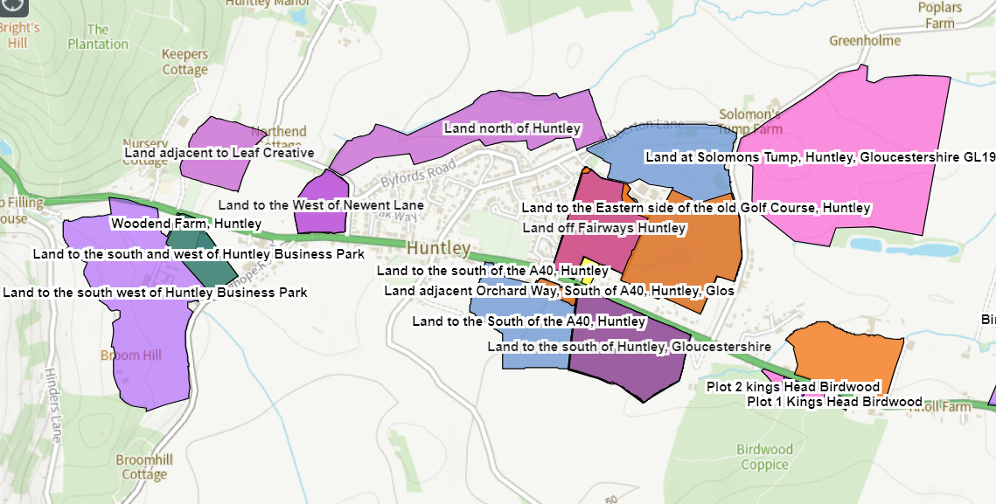

6. MINUTES OF PREVIOUS MEETINGS – Resolved that the minutes of the ordinary meeting held on 6th January 2026 and 2nd December form an accurate record.
7. LEAD MEMBER REPORTS:
A. PLAY AREA - Repairs to the area of wet pour under the slide remain outstanding. Contractor is waiting for a dry day to repair.
B. ALLOTMENTS – Council resolved to purchase a new sign with the wording ‘No Public Right of Way’.
Three half plots will become vacant in April and will be offered to those on the waiting list.
Councillor Walker presented a proposal for community orchard which was discussed but Council resolved to cancel the order for the fruit trees.
C. PUBLIC RIGHTS OF WAY - no report
D. TREES – Council agreed to plant the donated trees on the morning of 22nd February. Councillor Rebbeck has been donated 3 bags of compost. Clerk to purchase the mycorrhizal fungi.
E. VILLAGE HALL REPRESENTATIVE – no report
F. BIODIVERSITY – The snowdrop bulbs planted by the allotment fence have not yet appeared.
G. DEFIBRILLATOR – Council resolved to defer the application for another defibrillator due to the lack of a suitable location.
8. ACTION PLAN – To receive the contents of the Action Plan and to agree any new actions. Outstanding Actions:
- Clerk to engage Parish Online to create new website. Quote received.
- Councillor Green to report on whether a defibrillator could be placed by Morrisons on A40. This is not going to be possible.
- Councillor Rebbeck to strap the wooden upright and fixing that has come away on the climbing frame. Ongoing.
9. MAD HATTER’S TEA PARTY – To take place on Saturday 4th April.
- Councillor Evans to organise the raffle and sort the printing of raffle tickets. SMCS will sponsor this. Council resolved to purchase 400 raffle tickets.
- Councillor Evans has produced a poster. Council agreed to the number and size of these to be printed. SMCS to sponsor the printing.
- Councillor Green to plan the food. Cotswold Oak has offered to sponsor this with a donation of £100.
- Clerk to advertise on Facebook, Website , Noticeboard and PC Update
- Councillor Croxall to run tea and coffee stall
- Councillor Croxall to provide bunting
- Councillor Walker to organise the Lindt Bunny raffle – free entry for children
- Village Hall will charge £10 hour hire fee. The hall is currently booked 9am to 4pm. Council to agree booking times required.
- Require donations for the raffle, and judges for fancy dress and bonnet competition
10. PLANNING APPLICATIONS – To agree responses to recent applications, to ratify comments made between meetings and to note decisions.
A. Received – P0085/26/TPO Fell 1 x Oak Tree covered by A2 of Tree Preservation Order DFTPO 68. Huntley Manor, Newent Lane, Huntley.
P0063/26/LBC Maintenance repair works to the internal stairwell wall including removal of damaged plaster, reinstatement with traditional materials and a smooth plaster finish. The Old Rectory, Main Road, Huntley
P0058/26/LBC Investigation of apparent damp patches and removal of "Blown" Plaster. Removal of interior levelling bar within wall structure consumed with beetle. Repoint internal wall structure (stone and brick) with lime mortar. Replaster wall (internal) with lime plaster. The Old Rectory, Main Road, Huntley
B Responded – P1461/25/FUL Revised plans. Demolition of existing Conservatory and erection of single storey extension, The Cottage, Main Road, Huntley. Council objected to the application.
P0085/26/TPO Fell 1 x Oak Tree covered by A2 of Tree Preservation Order DFTPO 68. Huntley Manor, Newent Lane, Huntley. Council objected to the application.
P0063/26/LBC Maintenance repair works to the internal stairwell wall including removal of damaged plaster, reinstatement with traditional materials and a smooth plaster finish. The Old Rectory, Main Road, Huntley. Council supported the application.
P0058/26/LBC Investigation of apparent damp patches and removal of "Blown" Plaster. Removal of interior levelling bar within wall structure consumed with beetle. Repoint internal wall structure (stone and brick) with lime mortar. Replaster wall (internal) with lime plaster. The Old Rectory, Main Road, Huntley. Council supported the application.
C. Dealt with Between Meetings – none
D. Decided Since Last Meeting – none
E. Withdrawn Since Last Meeting – None.
F. Appeals – None.
11. FINANCE – Council received the parish accounts, authorised payments as detailed, noted income, spend against budget and reconciliation
(a) | Statement of Accounts as at 29th December 2025
 | Deposit Account | £ | 10,832.18
 | Treasurers Account | £ | 6187.62
 | Defibrillator Account | £ | 1,060.09
 | Play Area Ringfenced Funds Account | £ | 1061.79
(b) | Section 137 of Local Government Act 1972 | £ | 47.50
(c) | Adverse variance to budget (>£10) |  | 0
(d) | BACS Payments for Approval
 | Clerk Overtime (Jan) | £ | 299.60
 | Clerk Expenses (Jan) | £ | 46.28
 | HMRC (Feb) | £ | 114.93
 | Clerk Wages (Feb) | £ | 405.78
 | Pet Waste – Dog Fouling | £ | 190.08
 | Office of Police & Crime -Speeding letters | £ | 16.80
 | Village Hall | £ | 20.00
 | Ultra Vision - CCTV | £ | 90.00
 | R Watkins – bus shelter repairs | £ | 11.97
(e) | Payments made between meetings
 | M Evans – Allotment sign | £ | 14.78
 | Clerk Overtime (Dec) | £ | 144.83
 | Clerk Expenses (Dec) | £ | 34.79
 | HMRC (Jan) | £ | 114.93
 | Clerk Wages (Jan) | £ | 405.78
 | Village Hall | £ | 20.00
 | Bank Charges | £ | 4.75
 | Allotment waste cleanup | £ | 250.01
(f) | Income received since 1st December 2025
 | Bank Interest | £ | 6.04
 | Expenses:  Printing  Work From Home (Jan)  Stamps  Mileage |  | 4.50  26.00  6.96  8.82
12. COUNCIL EMAIL ADDRESSES – Removed from the agenda due to the resignation of Councillor Hill
13. IT POLICY – Council resolved to adopt the IT policy
14. PC UPDATE – Council agreed topics
15. MEETINGS/TRAINING/SEMINARS/CONSULTATIONS – Meeting held with PROW officer and Mr Snow regarding DHU39. Clerk to request update from FoDDC Planning regarding breach of planning permission for Baytree Farm
Council agreed that Councillor Walker will be the representative at FVAF meeting on 7 February 2026 at the Wilderness Centre, Mitcheldean. Meeting to discuss the biosphere
Regulation 18 consultation of FoDDC Local Plan at Huntley village hall, 28th February 2026 between 0900-1200 – public session
16. CORRESPONDENCE – FVAF meeting and Regulation 18 consultation
17. ITEMS FOR NEXT OR FUTURE MEETINGS – Response to Regulation 18 consultation of FoDDC Local Plan (due 18th March). Council resolved to agree a response at the next meeting rather than request a meeting with FoDDC
18. NEXT MEETING – Confirmed as Tuesday 3rd March 2026 at Huntley Village Hall.
19. MEETING CLOSED at 9.18pm
          $    %#  
&$'(')))($" 
*  '(        $            #   
#)(" 
+'(',!%##-.
" !/(0
 !%##

+ 1
#',
2"$'(',&$"""
""    3$      ""#!        
$4$
""

5 !#$"
    2  5    #$    25   $
$4""""
26 !"!
!17 
"""3$
2%""#"
5 $#"#
 !$ "
"$"
NDP Steering Group Update, August 2024

 !"#
"! 
          $    %#  
&$'(')))($" 
*  '(        $            #   
#)(" 
+'(',!%##-.
" !/(0
 !%##

+ 1
#',
2"$'(',&$"""
""    3$      ""#!        
$4$
""

5 !#$"
    2  5    #$    25   $
$4""""
26 !"!
!17 
"""3$
2%""#"
5 $#"#
 !$ "
"$"

